Data structures and Algorithms
Solution:
Exercise 2: E-commerce Platform Search Function
Big O Notation
Big O Notation describes how the running time of an algorithm grows as the input size increases.
Search Operations
Case | Linear Search | Binary Search
Best Case | O(1) | O(1)
Average Case | O(n) | O(log n)
Worst Case | O(n) | O(log n)

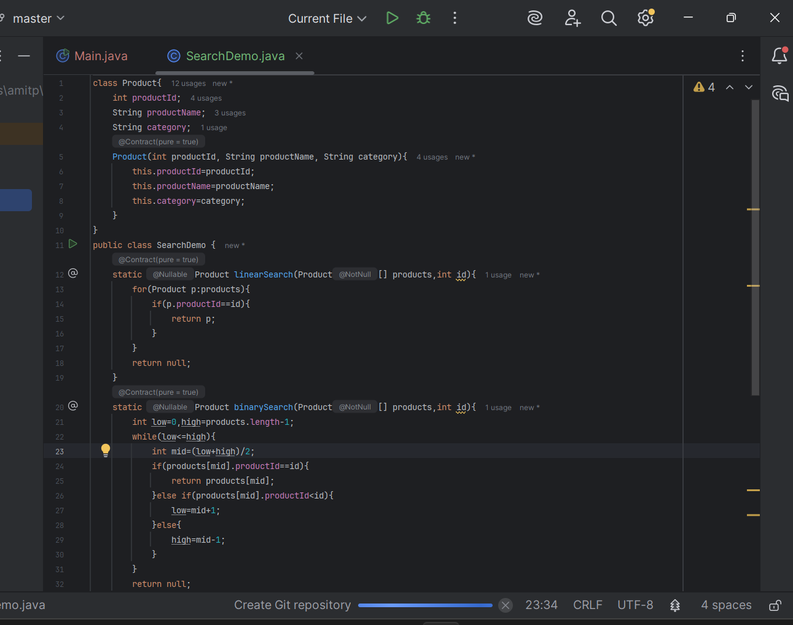
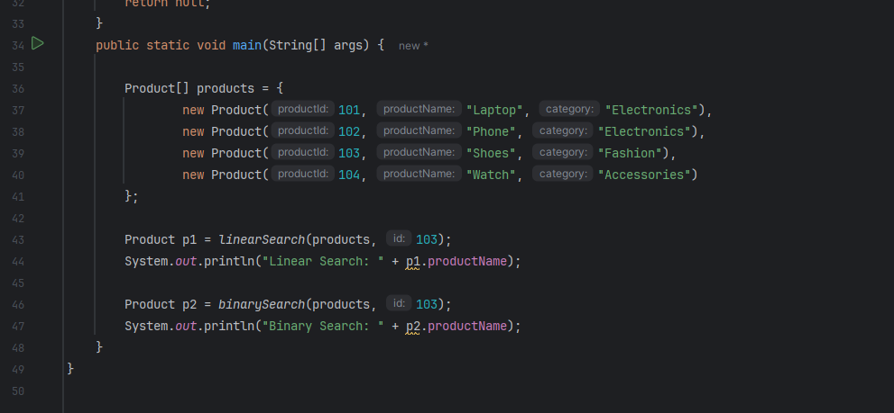
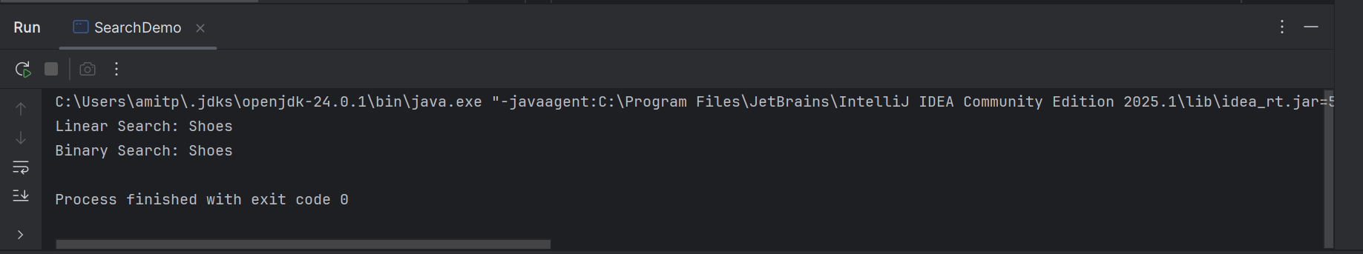
Analysis
Linear Search
- Checks elements one by one.
- Time Complexity: O(n)
- Works on unsorted data.
Binary Search
- Repeatedly divides the search space in half.
- Time Complexity: O(log n)
- Requires data to be sorted.
Suitable Algorithm for E-commerce Platform
Binary Search is more suitable because binary search can find products much faster (O(log n)) compared to linear search (O(n)), improving search performance and user experience.

Exercise 7: Financial Forecasting
Recursion is a technique where a method calls itself to solve a problem by breaking it into smaller subproblems.
A recursive method has:
- Base Case: Stops recursion.
- Recursive Case: Calls itself with a smaller input.
For financial forecasting, if a value grows by a fixed rate each year:
Future Value = Present Value × (1 + Growth Rate)^Years
This can be calculated recursively
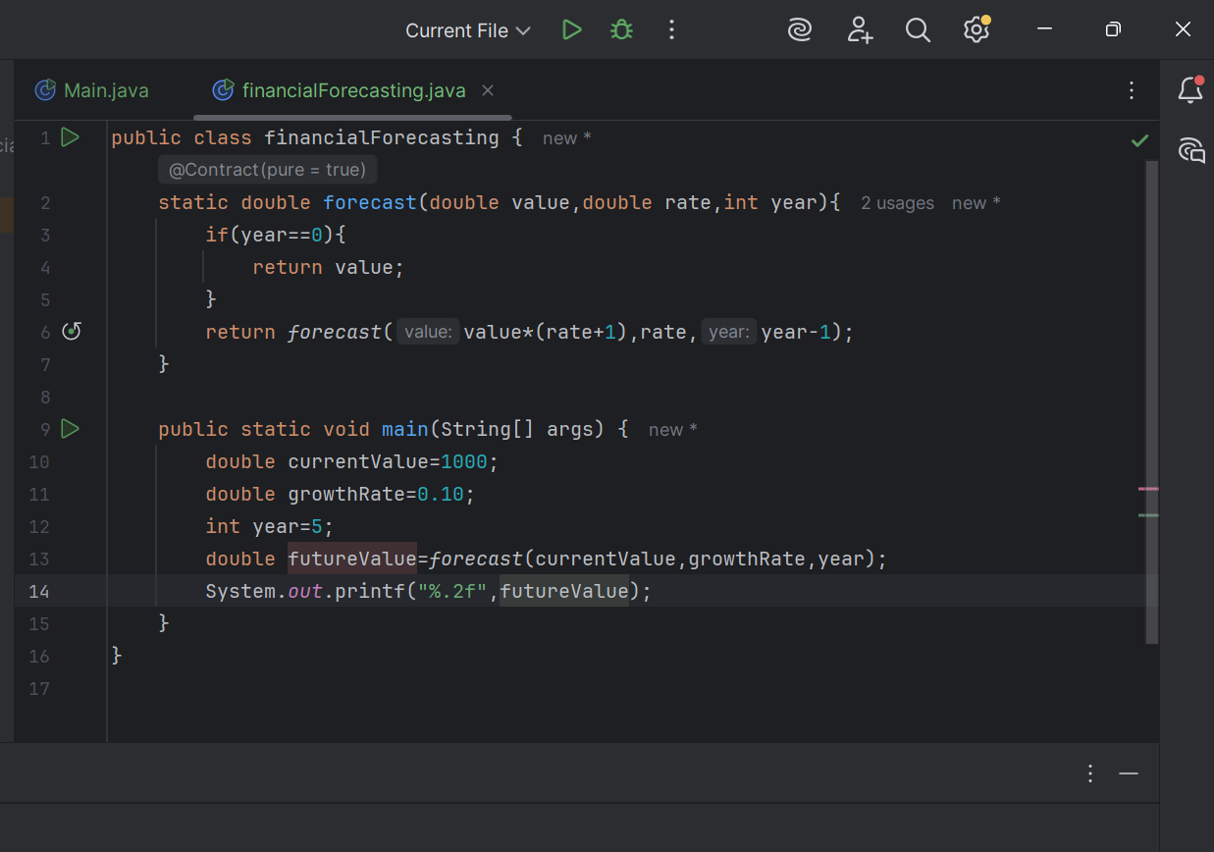
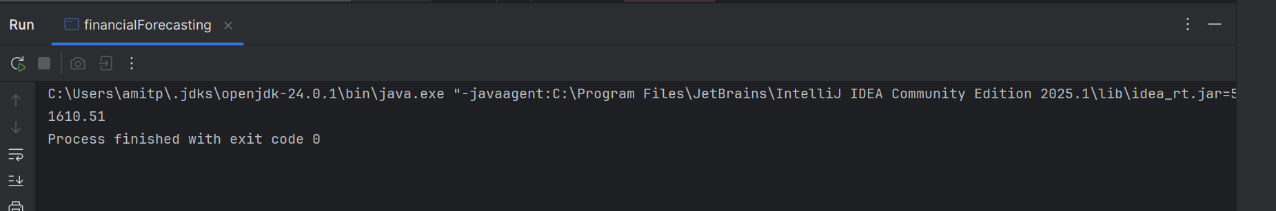

Analysis
Time Complexity
Each recursive call reduces years by 1.
Time Complexity: O(n)
Space Complexity: O(n) (due to recursive call stack)
Optimization
The above recursion is efficient because it makes only one recursive call per step.

